Beyond AI Detection: Building SignalLens

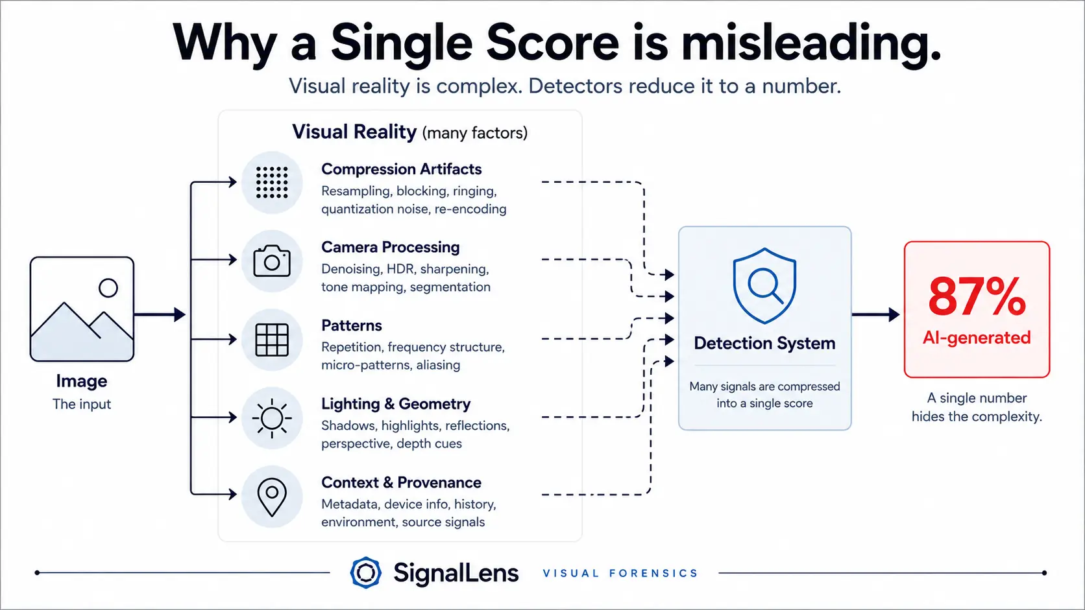
Figure 1: The Detector Problem

Toward Explainable Visual Forensics
A previous article exposed what I called the collapse of visual certainty. In short, it’s getting increasingly harder for us to make sense of our visual reality. The distinction between real and synthetic is becoming much less straightforward than so called AI detectors suggest.

If the problem is indeed more complex than binary AI detection, the question is, what does a better approach actually look like?

If single-score detection isn’t the solution, what should replace it? When current methods break down, we should explore a different forensic model.

The detector problem
We need a conceptual shift: from uncovering to reasoning. Instead of simply asking, 'Is this image generated?' we must probe the processes that contributed to this image becoming what it currently is.

This is possible because they leave traces that can be inspected by various forms of analysis and turned into signals we can interpret.

A multi-signal architecture
SignalLens approaches an image as a container of weighted signals. It acts as an evidentiary arbitration engine. Rather than hunting for a single smoking gun, it diverges its attention across three broad domains, searching for convergence and contradiction.

These three domains relate to the physical, the structural and the contextual attributes of the image.
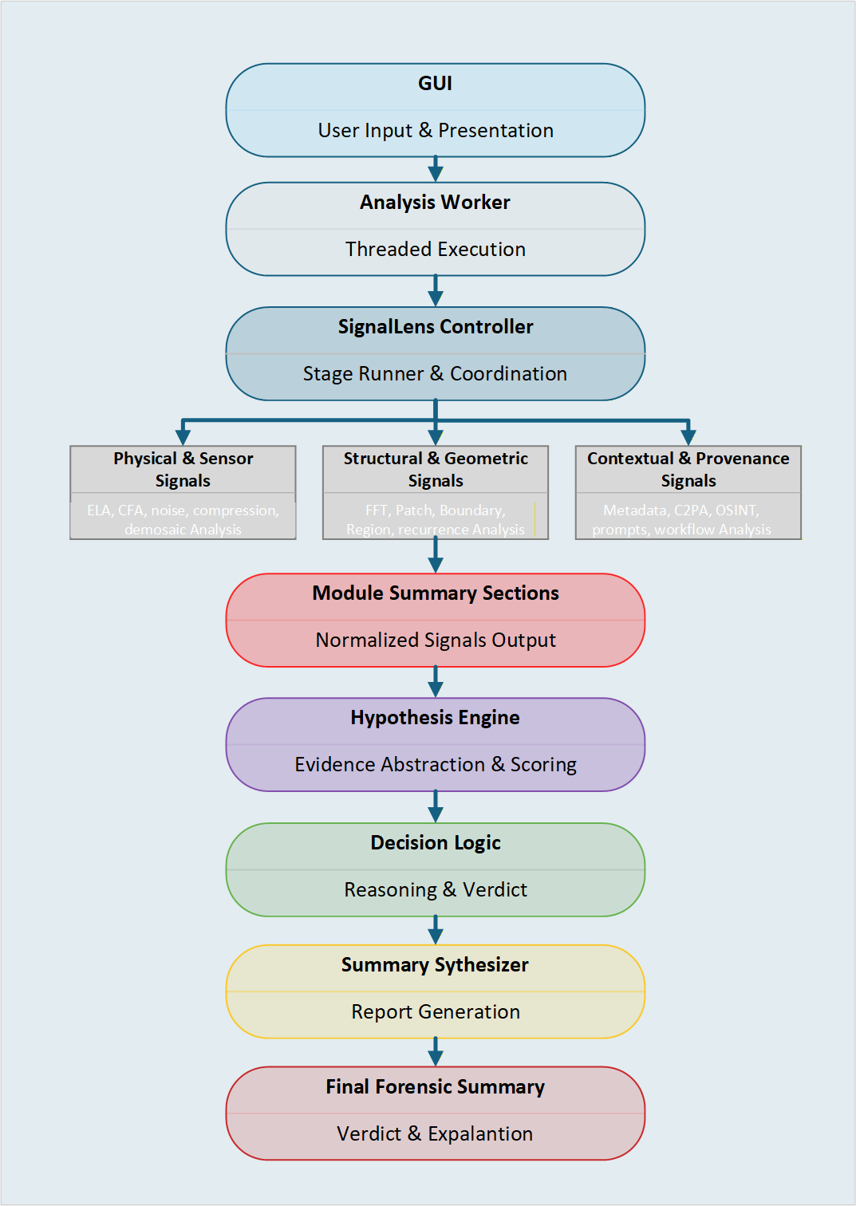
Figure 2, SignalLens Architecture

First, foundational physical evidence is provided by low level physics such as CFA-pattern, noise-variance and error-level-analysis.

If a perfect CFA pattern is found, the system assigns a massive benign (authentic) score. It’s very hard to fake this organically.

Second, structural & geometrical signals ignore the microscopic pixels and focus instead on the mathematical structure and repetition within the scene. These are critical for detecting localized manipulations—like generative fill, inpainting, or deepfake face swapping—where the underlying pixel physics might have been smoothed over, but the geometric structure is unnatural.

If structural signals flag a localized anomaly (like cloned patches), but the ground truth signals show a valid camera sensor background, the engine routes this to a ‘real photo, but manipulated’ pattern rather than a ‘fully synthetic’ pattern.

Third, declarative & contextual signals can act as modifiers. These signals do not inspect the image visually; they analyse its history and mathematical container. Metadata extraction, C2PA checking, and OSINT Reverse Search act as the gatekeepers for the entire decision engine.

If for instance C2PA metadata explicitly declares ‘Generative AI Tool’ or OSINT finds the image on a Midjourney prompt database, this heavily biases the scorecard toward synthetic, requiring overwhelming physical evidence to contradict it.

Ambiguity as a Feature
The true power of the SignalLens container is how it handles ambiguity and contradiction between signals. One of the most important design decisions in SignalLens was accepting that ambiguity is often meaningful.

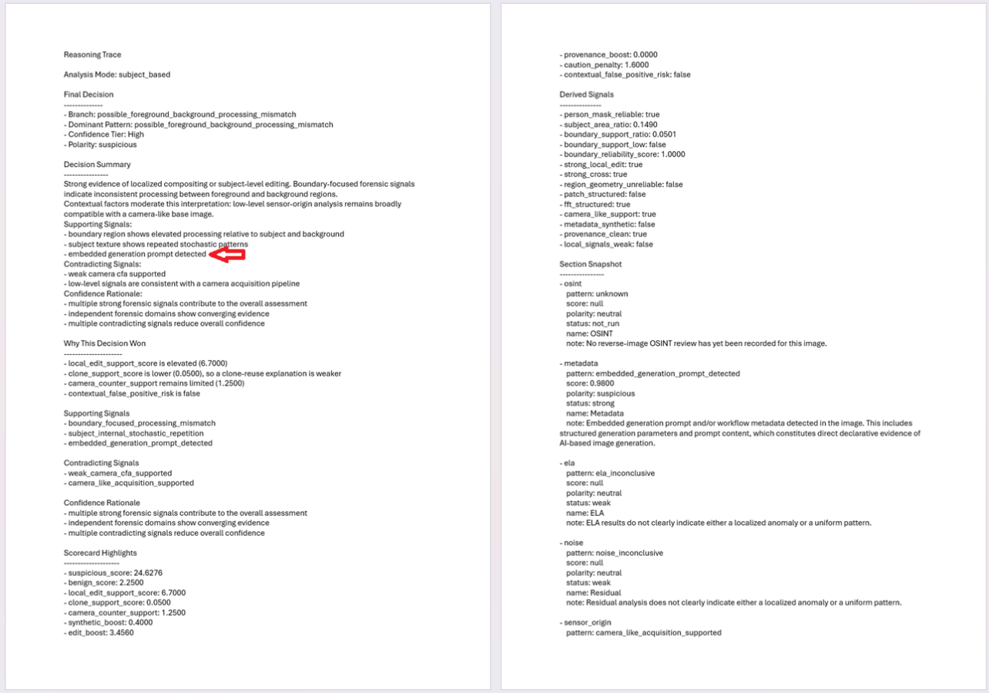
Figure 3, Reasoning Trace (2 of 5 pages shown)

A real smartphone photo can contain synthetic-looking artifacts. A generated image can contain realistic camera signals. An edited image can combine both.

Most tools fail because they compress anomalies into a percentage. SignalLens instead evaluates the tension between the signals.

If the high-level forensics in domain 2 scream fake, but the low-level physics form domain 1 scream real, the engine doesn't just average them to a useless "50% AI."

It recognizes the contradiction, extracts the specific benign and suspicious flags, and outputs a nuanced, explainable narrative: "The structural data is highly anomalous, but the presence of valid sensor noise suggests this may be a heavily computationally-processed real photograph rather than pure generative AI."

This multi-domain weighting is what allows SignalLens to reason about contradiction instead of collapsing it into a single score.

Note. In the reasoning trace, shown in Figure 3 above, notice the red arrow pointing to the evidence of the prompt used to generate this image. This demonstrates the strict discipline of the arbitration engine.

Even when faced with glaring declarative evidence (an embedded Stable Diffusion prompt), the system does not short-circuit to a 'smoking gun' conclusion. It continues to weigh the physical and structural domains independently, treating the prompt as a heavily weighted modifier rather than an absolute override. This prevents the system from being easily tricked by injected metadata.

The example image analysed in this article was sourced from a public Reddit discussion on photorealistic Stable Diffusion outputs and is used here strictly for analytical demonstration purposes.

Local Audit trail
A modern smartphone image may trigger:
- patch recurrence;
- localized smoothing;
- unusual texture regularization;
- HDR inconsistencies.
A naive detector may classify this as synthetic.
SignalLens instead compares these anomalies against:
- CFA evidence;
- sensor-origin indicators;
- metadata provenance;
- contextual processing patterns.
Result: not “AI-generated: 87%”
but: “Likely authentic photograph with aggressive computational processing.”
SignalLens is not a black box, every analysis produces a local forensic audit trail. SignalLens runs locally. Images do not need to leave the machine.

Every SignalLens analysis of an image creates a local forensic audit trail (under the folder .\analyzed\), with a dedicated folder for each image. This folder contains the evidence behind the conclusion: normalized versions of the image to be used by different analysis branches, visual overlays, heatmaps, masks, FFT outputs, metadata signals, JSON module results, logs, summaries in JSON, text and HTML, and a full reasoning trace in JSON and text. Adding up to (currently) 75 files.

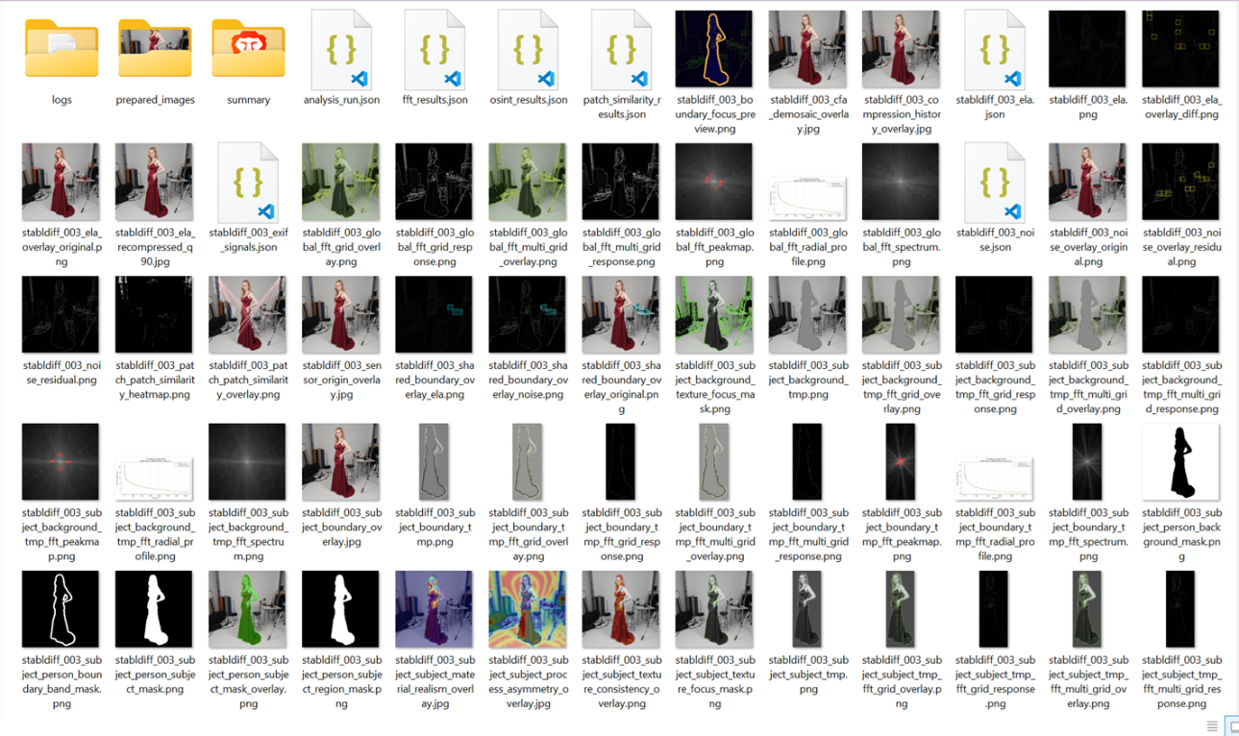
Figure 4: Local Audit trail

SignalLens does not just show a verdict. It preserves the evidence that led to it.

Conclusion: Visual certainty is changing
The future of synthetic media analysis may not belong to systems that pretend certainty exists everywhere. It may belong to systems capable of reasoning under uncertainty and that also provide you with the means to check its reasoning and the conclusions yourself.

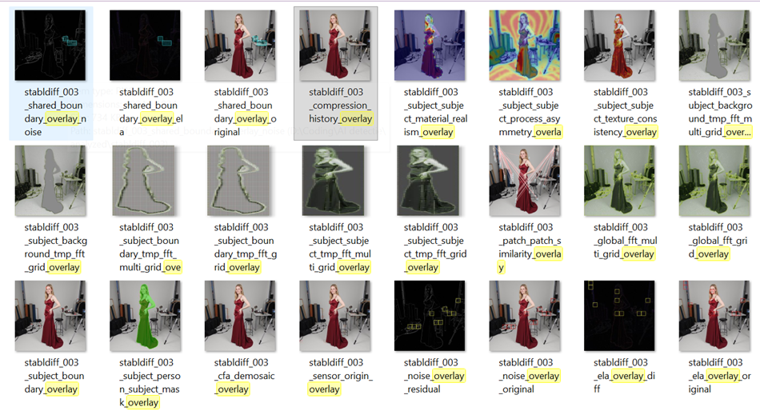
Figure 3, overlays.

Try SignalLens
SignalLens is currently being prepared in two local-first editions:

SignalLens Basic (Free): A lightweight local tool for everyday users and creators who need transparent verification.

SignalLens Pro: A comprehensive local workstation for OSINT investigators, journalists, HRM professionals, E-commerce platform managers and forensic analysts requiring advanced pixel analysis, the full 75-file audit trail, and customizable evaluation thresholds.

Join the early access waitlist here.

LinkedIn Version

Beyond AI Detection: Building SignalLens

If current AI image detection is breaking down, what should replace it?

That became the central question behind a project I’ve been building called SignalLens.

Most existing systems still approach synthetic media analysis as a classification problem:
You feed an image to a pre-trained classifier model and it returns a probability score.

But modern visual media no longer behaves that cleanly.

A real smartphone photo may contain:
- segmentation artifacts;
- HDR inconsistencies;
- texture regularization;
- aggressive denoising;
- computational relighting.

Meanwhile generated images increasingly imitate:
- camera noise;
- compression patterns;
- metadata;
- photographic structure.

So instead of asking: “Is this image AI-generated?” SignalLens approaches the problem more like a forensic reasoning system: “What processes likely contributed to this image?”

The system evaluates multiple independent domains.
🔍 Physical & Sensor Signals:
CFA structure, noise variance, ELA, compression history
🧩 Structural & Geometric Signals:
FFT structure, patch recurrence, localized inconsistencies
🌐 Contextual & Provenance Signals:
Metadata, OSINT reverse search, C2PA declarations, workflow traces

One of the most important design decisions made: ambiguity itself is treated as meaningful.

If one domain strongly suggests manipulation while another strongly supports authentic camera acquisition, the system does not collapse this contradiction into a meaningless “50% AI” score.
Instead, it produces an explainable forensic narrative describing the tension between the signals.

I’ve now published a second article exploring this framework and the architecture behind SignalLens:

“Beyond AI Detection: Building SignalLens”

#VisualForensics #ComputerVision #ImageAnalysis #ArtificialIntelligence #OSINT #SignalLens

Reddit

r/computervision

Why I stopped thinking of synthetic media analysis as a pure classification problem

Over the past months I’ve been working on a local forensic image-analysis project called SignalLens.

One of the main realizations during development was that modern synthetic media analysis increasingly breaks the assumptions behind traditional “AI detectors”.

A lot of current systems still effectively reduce the problem to: feed an image to pre-trained classifier and receive a probability score.

But real-world images are now often hybrid pipelines involving:
- smartphone computational photography;
- denoising;
- HDR fusion;
- Relighting;
- generative fill;
- inpainting;
- upscaling;
- Photoshop edits;
- multiple compression/re-encoding stages.

At some point, the question stops being: “Is this image AI-generated?” …and becomes more forensic, “What processes likely contributed to this image?”

That led me toward a multi-domain reasoning approach instead of a pure classifier approach.

The current system evaluates:
- physical/sensor signals (CFA structure, noise variance, ELA);
- structural/geometric signals (FFT structure, patch recurrence, localized inconsistencies);
- contextual/provenance signals (metadata, C2PA, OSINT traces).

One of the most interesting aspects was, that ambiguity itself becomes meaningful.

If structural signals strongly suggest manipulation while sensor-origin signals strongly support authentic acquisition, collapsing everything into “50% AI” destroys information.

Instead, the system attempts to explain the contradiction itself.

I wrote a longer article about the architecture and reasoning model behind this approach if anyone here is interested in the topic.

Curious how others in CV/forensics think about this direction. Do you think synthetic media analysis is evolving beyond pure classifier-based detection?

StableDiffusion Version

The more I worked on image forensics, the less convinced I became by binary “AI detectors”.

Working on a forensic image-analysis project over the past months led me to a somewhat ironic conclusion: the current “AI detector” framing increasingly feels inadequate.

Modern visual media pipelines are messy:
- diffusion generation;
- inpainting;
- upscaling;
- Photoshop;
- smartphone processing;
- re-encoding;
- platform compression.

Signals from all of these stages overlap and interfere with each other.
A lot of existing systems still try to collapse this into: “AI-generated: 92%”

But in practice the problem increasingly feels more like forensic interpretation under uncertainty.

The project I’ve been building (SignalLens) evolved away from pure classification toward multi-domain reasoning:
- physical/sensor analysis
- structural/geometric analysis
- provenance/context analysis

One interesting realization: sometimes the most important result is understanding why the signals conflict.

A real smartphone image can look synthetic. A generated image can imitate camera characteristics. Edited and generated regions can coexist in the same image.
So instead of binary answers, the system tries to construct explainable forensic narratives around the evidence.

I wrote a deeper breakdown of the framework and architecture if anyone here is interested.

